2024-25 Frequently Asked Questions

Program Overview
Who is eligible to apply?
When is the application deadline?
What is the Program timeline?
Is this award renewable?
Who administers this Program?

Award Details
What are the selection criteria?
What are the details of the award?
What are my responsibilities if I am chosen as a recipient?
How and when are funds issued?
How do I change my college choice?

Application Details
Which school should I list on the application if I have not made a final decision?
What is the difference between Official and Unofficial Transcripts?
What supporting documentation is required for this application?
Where and when should I send my supporting documents?

Notifications
How will I be notified about the status of my application?
What notifications will be sent to me?
Who will notifications be sent from?
When will I receive notifications?
Can I opt out of notifications?

Document Upload
What should be visible on my documents?
What are the acceptable file types?
Why can’t I upload a Word document?
One of the documents I uploaded has a status of Rejected. What do I do now?
How do I upload more than one file at a time?
How do I create a .zip file?
How long does it take to process my uploaded documents?
The deadline has passed and my documents are still Processing, what does that mean?
What are the DOs and DON’Ts of uploading documents to my application?

Application Status
How do I know if my application is Complete?
As the applicant, what are my responsibilities?
How do I use my Home page to verify my application status?
The deadline is tomorrow and it takes 1 day to process. Will I make it?
The deadline has passed and my application status is Started, what do I do?

Other Important Information
Are scholarships taxable?
ISTS Self-Help Portal
Contact Information

Home Page Tutorial
Help & My Profile
How to Apply
Application Status

Program Overview

Who is eligible to apply?
To be eligible for this award, you must meet all of the following criteria:
- Be the spouse of someone on active duty who has a rank of E6 or below and enlisted in the continental United States? of Texas.
- Be a high school senior, high school graduate or equivalent, or current post-secondary undergraduate student.
- Plan to attend an accredited college, university, or vocational/technical school in the United States in the Fall of 2024.

When is the application deadline?
April 18, 2024 at 11:59 PM Pacific Time Zone

What is the Program timeline?
- Application Open: March 6, 2024
- Application Deadline: April 18, 2024
- Notification of Selection Results: June 1, 2024
- Funds Disbursed: August 1, 2024

Is this award renewable?
No, this award is not renewable.

Who administers this Program?
To maintain a high level of professionalism and security, the program is administered by International Scholarship and Tuition Services, Inc. (ISTS), an independent company that specializes in managing sponsored educational assistance programs.
Award Details

What are the selection criteria?
An independent selection committee will evaluate the Complete applications and select recipients considering:
- Academic achievements and records
- Community service/Volunteerism
- Extracurricular activities
- Financial need
- Work/Internship experience
- Essay content
Decisions of the selection committee are final and are not subject to appeal. No application feedback will be given.

What are the details of the award?
- Awards in amounts up to $10,000 will be awarded annually and are not renewable.
- Students may reapply each year as long as they continue to meet the eligibility criteria.
- Scholarships will be applied to tuition, fees, books, and supplies required for course work at accredited institutions in the United States. These institutions include: two-year colleges, four-year colleges, vocational schools, technical schools. Students may transfer from one institution to another and retain the award.
- Scholarships may not be applied to room and board and cannot be used to purchase a laptop if not required for all students attending the institution or course.

What are my responsibilities if I am chosen as a recipient?
You must enroll as a full-time or part-time undergraduate student in the fall of the year in which the scholarships are awarded. You must continue the entire academic year without interruption unless approved by the scholarship sponsor. You are responsible for delivering your scholarship check(s) to the proper office at your institution with its attached instructions. You should notify ISTS should your check not arrive within 30 days of the issue date. You will receive an email notification when your funds are issued.

How and when are funds issued?
Your funds will be issued via check in early August. Your check will be made payable to your institution listed on your My Profile page only. Your scholarship check cannot be made payable to you, the applicant. The check will be mailed to your home address so that you may deliver it to the correct office at your institution. You will receive an email notification once your funds have been issued.
How do I change my college choice?
Make sure your My Profile page indicates your final college choice. It is your responsibility to make sure your My Profile page is correct at least 30 days prior to the check issue date listed above. If your scholarship check needs to be reissued for any reason, a reissue fee may apply.

Application Details

Which school should I list on the application if I have not made a final decision?
You should list your first-choice school on the application. You can change your college choice any time prior to the application deadline. If selected as a recipient, you will be asked to confirm your final school choice. If your school changes after the acceptance deadline, you will be able to update this information on your My Profile page.

What are the differences between Official and Unofficial Transcripts?

Official transcripts must be obtained through your high school administration office, or your college registrar office. Transcripts are normally printed on official letterhead and/or state that they are official. Transcripts may contain or require a signature.
Note: Your official transcript may come to you in a sealed envelope, stating it will become unofficial if opened. When scanning or copying your official transcripts, a watermark may appear noting that they are now unofficial. Despite any watermarks or sealed envelopes, you may open the envelope if needed to upload the document. These documents will be considered official for our purposes. Acceptable file types are .pdf, .tif, .png, .jpeg, .jpg, .bmp and .xps. When scanning or copying, you do not need to include a copy of the sealed envelope.

Unofficial transcripts may be accessed through your school’s online student portal. These pages must still be converted to one of the acceptable file formats. Unofficial transcripts must contain your name.

What supporting documentation is required for this application?
- High School Transcript or Proof of GED: Upcoming College Freshmen and Sophomores only.
- College/University Transcript: Upcoming College Sophomores, Juniors, and Seniors only.
- Most recent 1040 Tax Return showing Adjusted Gross Income (AGI): All applicants
- Most recent Leave Earnings Statement: All applicants
- Military Spouse ID: All applicants

Where and when should I send my supporting documents?
All required supporting documents must be uploaded to your online application by the application deadline. If you do not follow the upload instructions exactly, your application may remain incomplete. Documents that meet the criteria required for this application that are uploaded by the deadline will be processed and considered on time.

Notifications

How will I be notified about the status of my application?
Notifications are sent primarily via email to the email you used to create your account. Some programs offer text and voice notifications. Ultimately, it is your responsibility as the applicant to verify your application status on your Home page is Complete.

What notifications will be sent to me?
- Deadline Reminders: Deadline reminder emails are typically sent two weeks and one week prior to the application deadline.
- Selection Results: Selection results notifications are sent to all Complete applicants.
- Funds Disbursed: Once your funds have been issued, you will be notified.
- Other Scholarships: Occasionally, if you meet the requirements for another scholarship administered by ISTS, you will be notified. These notifications are not guaranteed.
Your information is never sold to any third party for marketing purposes.

Who will notifications be sent from?
You will receive notifications from two possible ISTS email addresses: donotreply@applyISTS.com and ContactUs@applyISTS.com. You should add both of these email addresses to your “safe senders list” to ensure important emails are not sent to your spam or junk folder.

When will I receive notifications?
Notifications vary by program based on the Program timeline. Refer to the Program timeline listed above for more specific information. Typically, deadline reminders are sent two and one week prior to the application deadline.

Can I opt out of notifications?
While you can opt out of notifications, this is not advised. It is your responsibility as the applicant to ensure your application is Complete. If you opt out of notifications, you will not receive deadline reminders or selection results. Your information is never sold to any third party. The only emails you will receive from ISTS are directly related to your application and, possibly, other scholarship opportunities.

Document Upload

What should be visible on my documents?
All uploaded documents must show your name. If you are using an online portal to access your required documentation and all that is visible is the salutation and your first name (Example: Welcome Joe!), this will meet the name requirement.

What are the acceptable file types?
The only acceptable file types are .pdf, .tif, .png, .jpeg, .jpg, .bmp and .xps. Any other formats will not be reviewed, and your application will remain incomplete. You may upload multiple files within a .zip file. All files within a .zip file must be in one of the acceptable file types listed above.

Why can’t I upload a Word document?
ISTS does not accept any file format that is editable.

One of the documents I uploaded has a status of Rejected. What do I do now?
Review the reason your document was rejected. Once you have corrected that issue, upload a new copy of your document.

How do I upload more than one file at a time?
You may create a .zip file containing more than one file as long as everything included is in an acceptable file type of .pdf, .tif, .png, .jpeg, .jpg, .bmp and .xps. Do not upload additional documentation that is not requested. It will not be reviewed.

How do I create a .zip file?
To use this format, follow the steps outlined below:
- Create a new folder on your Desktop, name it the document type you will be uploading. For example, Test Scores, Transcript, or Financial Documentation.
- Move all the files you wish to upload into the new folder.
- Right click on the folder from your Desktop:
  - PC Users: select “Send to,” followed by “Compressed (zipped) folder.”
  - Mac Users: select “Compress [folder name].”
- Your new .zip file will be located on your Desktop, ready to upload.

How long does it take to process my uploaded documents?
Documents are processed daily. Your document will be processed within 1 business day. If your document was uploaded prior to the deadline, it will be considered. However, it is your responsibility to monitor your Home page to ensure your document is Accepted.

The deadline has passed and my documents are still Processing- what does that mean?
All documents must be reviewed for the required information and for accuracy. All documents uploaded prior to the application deadline will be reviewed and considered. It is your responsibility to monitor your Home page to ensure your document is Accepted and that your application status reads Complete.
What are the DOs and DON’Ts of uploading documents to my application?

DO:
- Upload one of the accepted file types.
- Only upload the requested and required documents.
- Black out any Social Security Numbers. This is not required, but highly advised.
- Return to your Home page to verify your documents have been Accepted.

DON’T:
- Upload a Microsoft® Word document (.doc, .docx) or any other format we don’t accept.
- Upload more than the requested documentation.
- Assume your documents are correct and accepted once you have uploaded them.
- Upload a document stating you are mailing your documents.
- Assume the required document does not pertain to you. If the application states the document is required, your application will remain incomplete if you do not provide that document. Contact us if you are having trouble providing a required document.
- Password protect your uploaded documents. Password protected documents will be rejected.
- Upload any file that has a viewing expiration date.

Application Status

How do I know if my application is Complete?
Complete applications will have a green COMPLETE button, as shown below:

If your application status has a grey or orange STARTED button as shown below, click the button to view the status of each individual requirement.

As the applicant, what are my responsibilities?
It is your responsibility to make sure your application is Complete. Your online application form must be Submitted, all required documents uploaded and Accepted.

How do I use my Home page to verify my application status?
When you log in to your Home page, you will see all applications listed. Each application will have an overall status button visible to you.

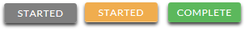

A grey STARTED button means you have not submitted your online form. An orange STARTED button means you have submitted the online form but you are either missing required items for the application, or your documents are still processing.

When you click the status button, you will see the more detailed status. This will show you the status of each individual required portion of the application. For more details on your Home page, review the Home Page Tutorial section.

The deadline is tomorrow and it takes 1 day to process. Will I make it?
As long as your documents were uploaded prior to the application deadline, they are considered. You should continue to monitor your Home page until you see the status update to ACCEPTED. If the status updates to REJECTED, contact us immediately.

The deadline has passed and my application status is Started, what do I do?
If your STARTED button is grey, you have unfortunately missed the deadline and your application is now read only. If your STARTED button is orange, click the button to view what is missing. Your required documents may be PROCESSING. As long as your documents were uploaded prior to the application deadline, they are considered. You should continue to monitor your Home page until you see the status update to ACCEPTED. If the status updates to REJECTED, contact us immediately.

Other Important Information

Are scholarships taxable?
Tax laws vary by country. In the United States, scholarship funds used exclusively for the payment of tuition and textbooks are normally not taxable. The scholarship recipient is responsible for taxes, if any, that may be assessed against his or her scholarship award. We recommend consulting your tax adviser for more guidance. You may also consult IRS Publication 970 for additional information.

ISTS Self-Help Portal
For more helpful information about scholarships plus answers to common inquiries related to ISTS’ technology and processes, visit our Self-Help Portal at ISTSprogramsupport.com.

Contact Information
ISTS office hours are Monday through Friday from 7:00 AM to 7:00 PM and Saturday 9:00 AM to 6:00 PM Central Time. Program Support Agents are available via live chat and email during these hours. Use the green Help button (as shown below) at the bottom right corner of your screen to contact us.

Home Page Tutorial

Your ISTS Home page is located at https://aim.applyISTS.net. This will show you all of your applications and their overall status. It is your responsibility as the applicant to monitor your Home page to ensure your application is Complete.

Help and My Profile
In the top right corner of the page, you’ll find the HELP link to the ISTS Help Portal and your My Profile page.

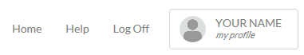

How to Apply
To start an application, click ADD NEW APPLICATION. You will then be asked for the Program Key. If you do not know the Program Key, try the name of the company or organization offering the award.

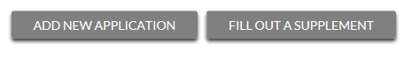

As the applicant, you will not click FILL OUT A SUPPLEMENT. This will be used only by a third party completing a required supplement form for your application. Not every application requires a supplement. Make sure you review the requirements for each application.

Applications View
Each application will have its own box. You will see the program name, application link, and Status Button.

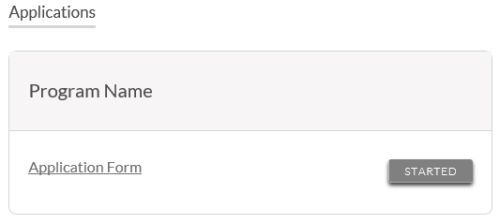
Application Status Buttons
Each application will have one of the following Status Buttons:

If your status button is grey, it means you have not yet clicked the Submit button on the last page of your application. If your status button is orange, it means you have clicked Submit but you are missing one or more required documents or supplements for that application.

For a detailed status of each application requirement, click the Status Button.

Detailed Status View
Once you click the Status Button, your detailed status view will appear. Below is an example. Next, we’ll review what each of these statuses mean.

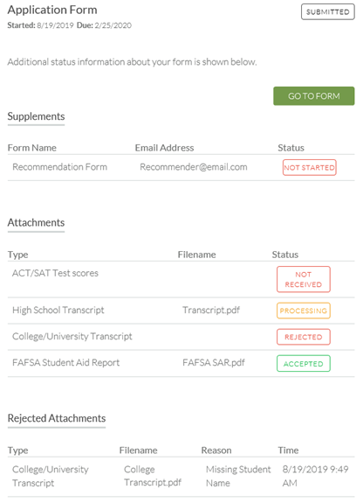
Application Form Section
This top section shows you the date you started the application, application deadline date, status of your form and provides a button to return to your application.

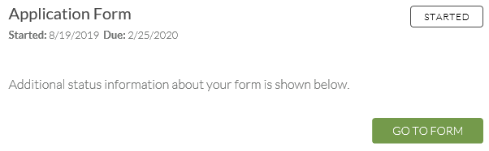

If you have submitted your online application form, the status would read:

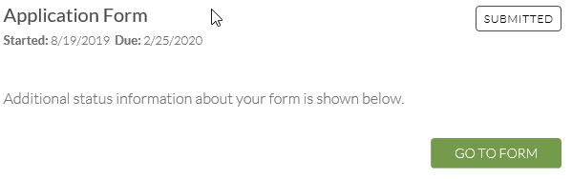

Supplements Section
This section allows you to track the progress of your required supplement forms. Some programs require this information to remain confidential. In those cases, you will not see the status of the form. It is simply your responsibility to make sure the person completing that supplement form received the instructions. Not all applications require a supplement. Make sure you review the application requirements for each application.

When your supplement has been requested but not started, you will see the status NOT STARTED:

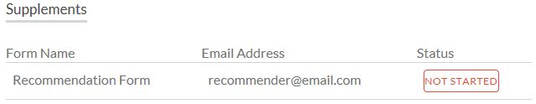

Once the supplement has been started, you will see the status STARTED:

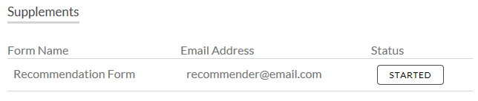

Once the supplement form is submitted, you will see the status COMPLETE:

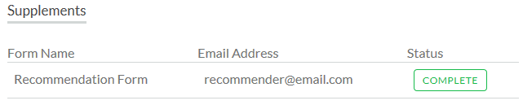

Attachments Section
This section allows you to track the status of each required attachment or supporting document(s) for your application. Not all applications have required attachments. Make sure you review the application requirements for each application.

There are four attachment statuses:

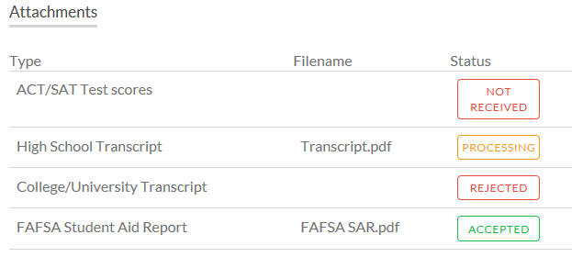

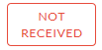
This means you have not yet uploaded this attachment and it is required for your application be considered Complete.

This means your attachment has been uploaded and is currently pending review by ISTS. Attachments are processed within 1 business day. All documents uploaded prior to the application deadline will be considered.

This means the document you uploaded was not acceptable. Below the attachment section is the Rejected Attachment section. This will tell you why your attachment was rejected.

This attachment has been reviewed by ISTS and has been verified as meeting all of the requirements needed for that attachment.

Rejected Attachments Section
If you have uploaded a document that does not meet the minimum requirements for the application, your document will be rejected. Your attachment status will read:

You will see the attachment type, file name, the reason for rejection and the date/time your document was rejected.

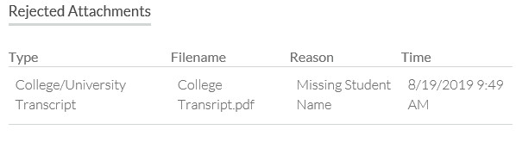

To upload a corrected document, simply click GO TO FORM and upload your document. Make sure you have fixed any of the issues noted in the reason for rejection so that your document is not rejected a second time.

If the application deadline has passed and your application is not Complete because your document was rejected after the application deadline it is important that you contact us immediately so that we can assist you. Most programs allow ISTS to help you correct a rejected document within the 1 business day processing time after the deadline. However, this is not guaranteed. Make sure you follow the Upload Instructions within your application to ensure your document meets all minimum criteria.

